**Topics: Descriptive Statistics and Probability**

1. Look at the data given below. Plot the data, find the outliers, and find out $μ, σ, σ^{2}$

|  |  |
| --- | --- |
| **Name of company** | **Measure X** |
| Allied Signal | 24.23% |
| Bankers Trust | 25.53% |
| General Mills | 25.41% |
| ITT Industries | 24.14% |
| J.P.Morgan & Co. | 29.62% |
| Lehman Brothers | 28.25% |
| Marriott | 25.81% |
| MCI | 24.39% |
| Merrill Lynch | 40.26% |
| Microsoft | 32.95% |
| Morgan Stanley | 91.36% |
| Sun Microsystems | 25.99% |
| Travelers | 39.42% |
| US Airways | 26.71% |
| Warner-Lambert | 35.00% |

μ: 33.27133333333333

σ: 16.370812590976932

σ^2: 268.00350488888887

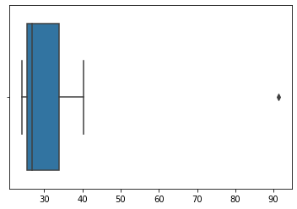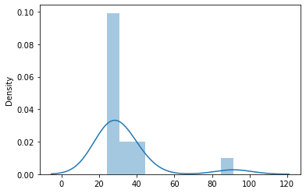



Answer the following three questions based on the boxplot above.

1. What is the inter-quartile range of this dataset? (Please approximate the numbers) In one line, explain what this value implies.

IQR = Q3 – Q1

APPROXIMATELY

IQR = 12 – 5 = 7

1. What can we say about the skewness of this dataset?

RIGHT SKEWED (POSITIVE SKEWNESS)

1. If it was found that the data point with the value 25 is actually 2.5, how would the new boxplot be affected?

* There will be no outliers.
* Mean and median must be calculated to see if there is any change in data.



Answer the following three questions based on the histogram above.

1. Where would the mode of this dataset lie?

As we can see from the histogram Mode of the dataset would lie in between 3 and 10.

1. Comment on the skewness of the dataset.

RIGHT SKEWED (POSITIVE SKEWNESS)

1. Suppose that the above histogram and the boxplot in question 2 are plotted for the same dataset. Explain how these graphs complement each other in providing information about any dataset.

Both are POSITIVELY SKEWED, and both give the value of outlier as 25.

1. AT&T was running commercials in 1990 aimed at luring back customers who had switched to one of the other long-distance phone service providers. One such commercial shows a businessman trying to reach Phoenix and mistakenly getting Fiji, where a half-naked native on a beach responds incomprehensibly in Polynesian. When asked about this advertisement, AT&T admitted that the portrayed incident did not actually take place but added that this was an enactment of something that “could happen.” Suppose that one in 200 long-distance telephone calls is misdirected. What is the probability that at least one in five attempted telephone calls reaches the wrong number? (Assume independence of attempts.)

Probability of calls getting misdirected

= 1 /200 🡺 0.005

Probability of call not misdirecting

= 1 - (1/200) 🡺199/200 🡺0.995

1– Probability of at least one of five is not wrong number

= 1-(1-0.005) ^5

= 0.024

1. Returns on a certain business venture, to the nearest $1,000, are known to follow the following probability distribution

|  |  |
| --- | --- |
| x | P(x) |
| -2,000 | 0.1 |
| -1,000 | 0.1 |
| 0 | 0.2 |
| 1000 | 0.2 |
| 2000 | 0.3 |
| 3000 | 0.1 |

1. What is the most likely monetary outcome of the business venture?

Since the highest probability is 0.3, the most likely outcome would be 2000

1. Is the venture likely to be successful? Explain

P(x=1000) + P(x=2000) + P(x=3000)

= 0.2 + 0.3 + 0.1 🡺 0.6

YES, the venture is going to be successful.

1. What is the long-term average earning of business ventures of this kind? Explain

The long-term average earning of the business will be = Σx*P(x)

🡺(-2000*0.1) + (-1000*0.1) + (0*0.2) +(1000*0.2) + (2000*0.3) + (3000*0.1)

🡺800

1. What is a good measure of the risk involved in a venture of this kind? Compute this measure

Risk involved in venture is the standard deviation

i.e., 1089.98